Responsive Portfolio Website

Submitted by:
S. Gracelin Jasper
Department:
Computer Science and
Engineering
Institution:
Francis Xavier
Engineering College
Academic Year:
2024 – 2025
Introduction
A portfolio website is a personal website that showcases an individual’s skills, projects, and contact information in a professional manner. With the increasing use of mobile devices, it is important for websites to be responsive and accessible across different screen sizes.
This project focuses on developing a responsive personal portfolio website using HTML, CSS, and Bootstrap. The website includes sections such as Home, Skills, Projects, and Contact. Bootstrap is used to ensure responsiveness and mobile-friendly design.

Objective of the Project
- The main objectives of this project are:
- To design and develop a personal portfolio website
- To make the website fully responsive across all devices
- To implement smooth scrolling navigation
- To showcase skills and projects in an organized manner
- To host the website using GitHub Pages

Tools and Technologies Used
HTML – For structuring the web pages
CSS – For styling and layout
Bootstrap – For responsive design and components
GitHub – Version control and code hosting
GitHub Pages – Live website hosting
System Requirements
- Hardware Requirements
- Laptop or Desktop Computer
- Minimum 4 GB RAM
- Software Requirements
- Web Browser (Google Chrome / Microsoft Edge)
- Visual Studio Code
- Internet connection

Project Description
The portfolio website consists of the following sections:
Home Section
The home section introduces the user with a brief description and a call-to-action button to view projects.
Skills Section
This section displays the technical skills of the user such as HTML, CSS, Python, and C programming.
Projects Section
The projects section lists sample projects developed by the user, giving an overview of their practical knowledge.
Contact Section
The contact section provides email and GitHub information for communication.

Features of the Project
Responsive design using Bootstrap
Smooth scrolling navigation bar
Mobile-friendly layout
Simple and clean user interface
Hosted live using GitHub Pages

Advantages
Easy to use and navigate
Works on mobile, tablet, and desktop devices
Professional presentation of skills
Improves online presence

Code Snippets
HTML Snippet
<nav class="navbar navbar-expand-lg navbar-dark bg-dark fixed-top">
<div class="container">
<a class="navbar-brand" href="#">Gracelin</a>
<ul class="navbar-nav ms-auto">
<li class="nav-item"><a class="nav-link" href="#home">Home</a></li>
<li class="nav-item"><a class="nav-link" href="#skills">Skills</a></li>
<li class="nav-item"><a class="nav-link" href="#projects">Projects</a></li>
<li class="nav-item"><a class="nav-link" href="#contact">Contact</a></li>
</ul>
</div>
</nav>

Bootstrap Grid
<div class="row">
<div class="col-md-4">HTML</div>
<div class="col-md-4">CSS</div>
<div class="col-md-4">Python</div>
</div>

CSS Snippet
html {
scroll-behavior: smooth;
}

Output Screenshots
On PC:
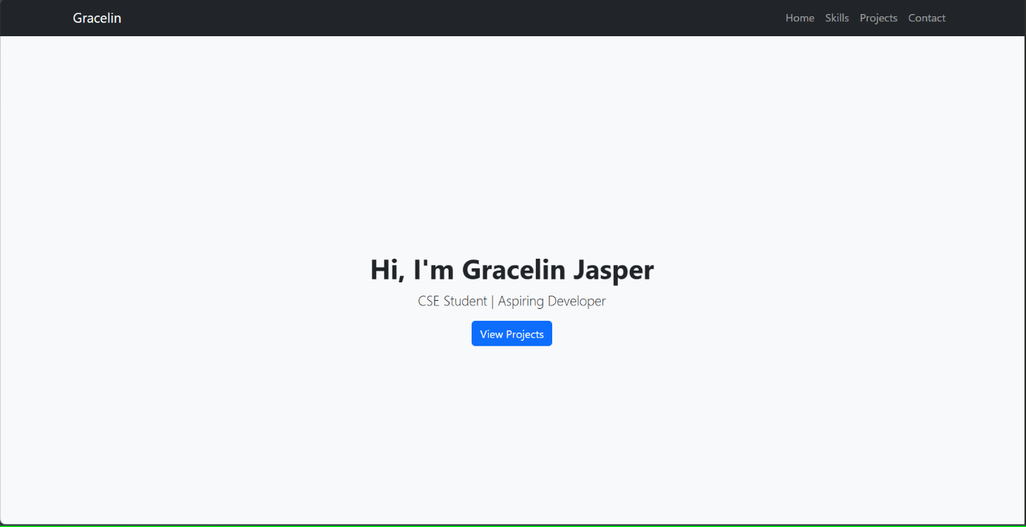

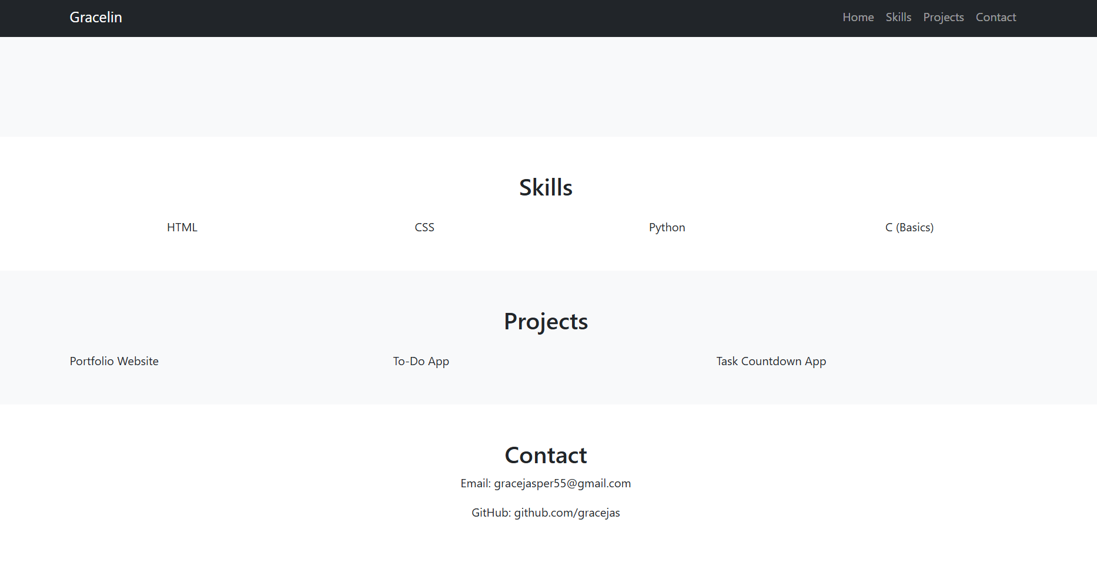

On Mobile:
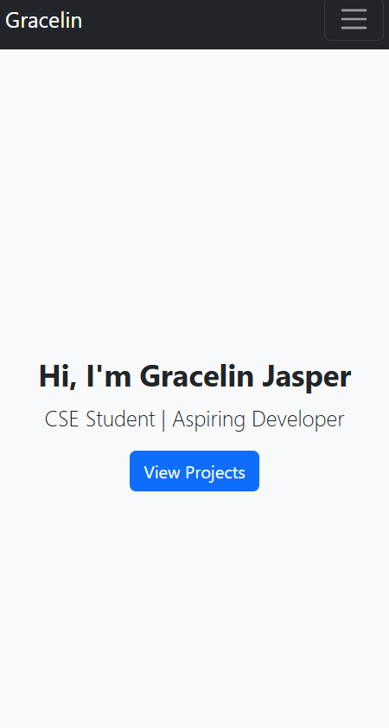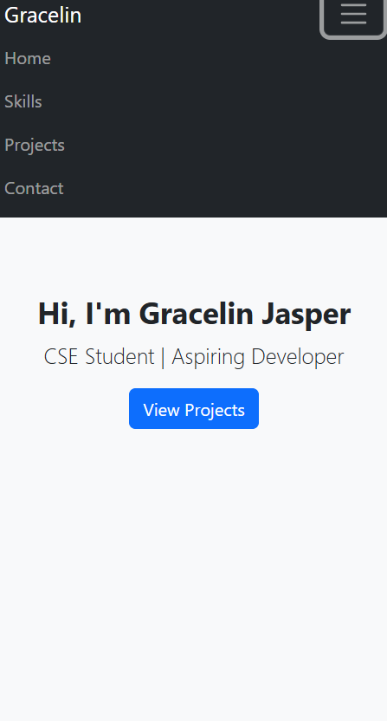

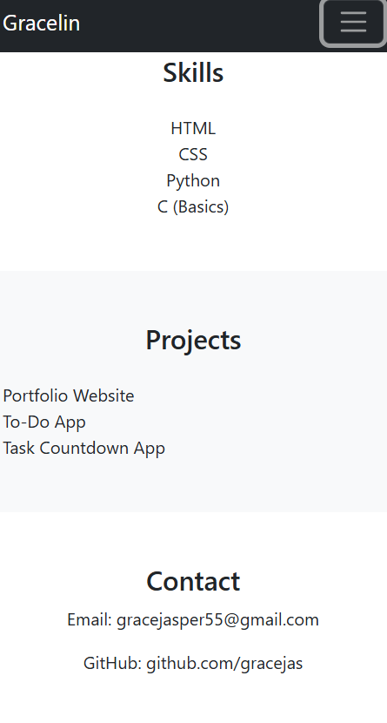
Live Website Link
GitHub Pages Link:
https://gracejas.github.io/portfolio/

GitHub Repository Link
Source Code Link:
https://github.com/gracejas/portfolio

Conclusion
In this project, a responsive portfolio website was successfully developed using HTML, CSS, and Bootstrap. The website adapts to different screen sizes and provides a professional way to showcase personal information, skills, and projects. Hosting the website on GitHub Pages makes it accessible online. This project helped in understanding responsive web design concepts and front-end development tools.

